EXERCISE-36

36. Design NFA using simulator to accept the string the start with a and end with b over set {a,b} and check W= abaab is accepted or not.

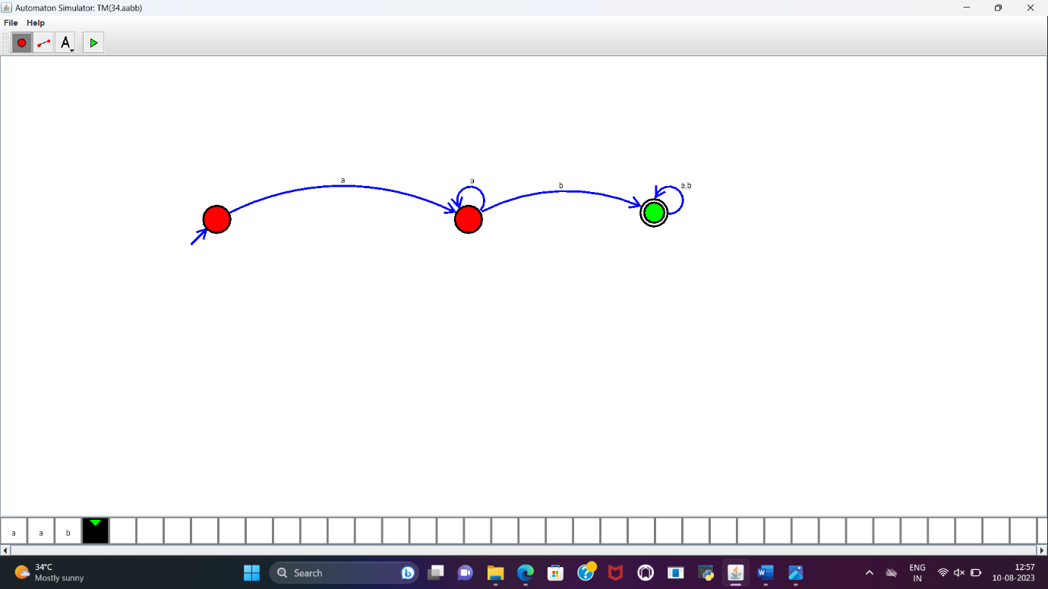

RESULT:

NFA to accept the string that start with a and end with b is designed and implemented successfully.